Office/Centre Name
Address
Postcode
Council Area
Main Telephone

Youth Service
Staff & Administration Workspaces
Risk Assessment
(Covid-19)

July 2020

LIST OF ASSESSED RISKS
Spread of Covid-19 through employees and out into wider community. 5
Suspected or confirmed case in office setting. 7
Suspected or confirmed case in staff member or with a family connected to the work environment. 8
Lone Working, Stress, anxiety 9
Risk of Fire 10

Sign off and Approval
Completed By
Approval

Risk Assessment Matrix
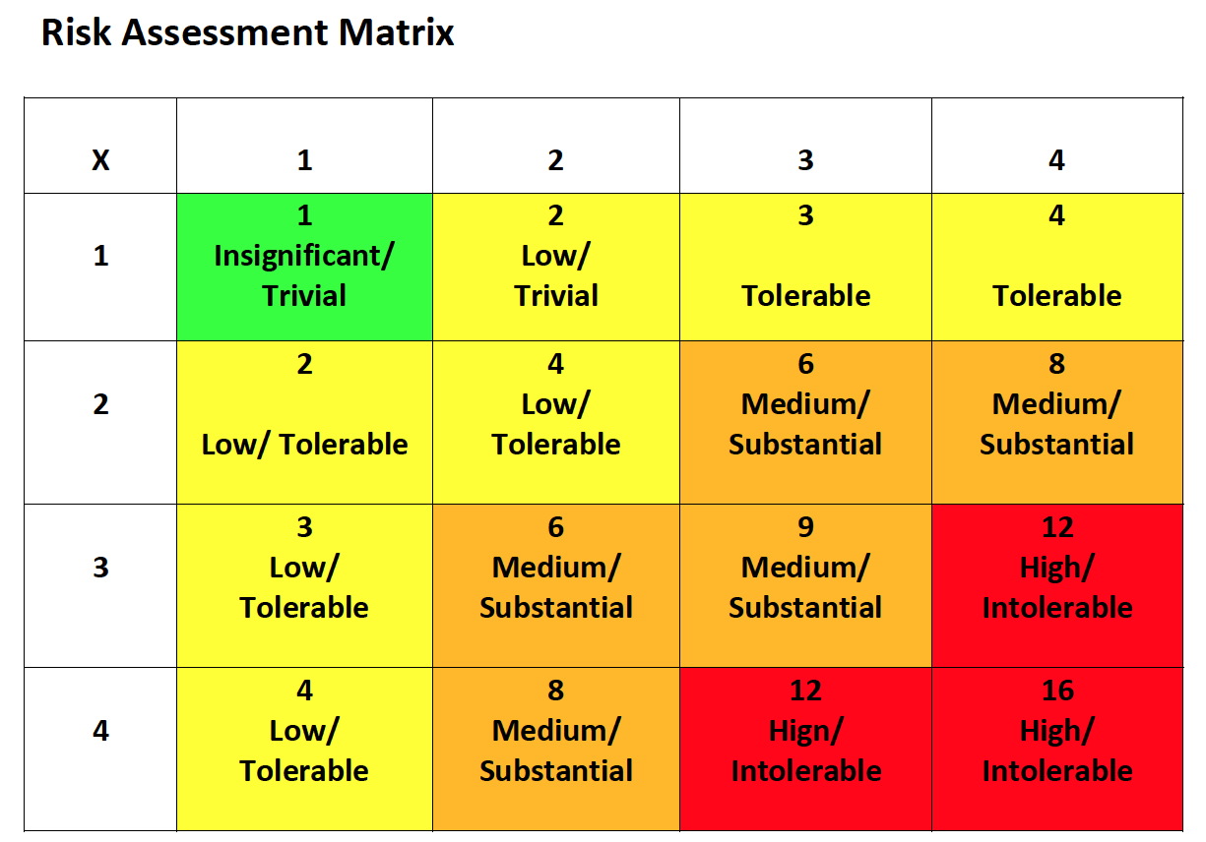

Completed by: Date: Review Date: Ongoing
Hazard | To Whom | Severity | Likelihood | Risk
Spread of Covid-19 through employees and out into wider community. | Staff | 3 | 3 | 9
 | Visitors/Contractors | 3 | 3 | 9
 | Wider Community | 3 | 3 | 9
Existing Precautions |  | Additional Precautions | Who | When
- Only a skeleton staff are currently working in offices, majority of staff are working from home. Work schedules have been reviewed to reduce number of workers on site at any one time.
- Redesigning processes and layout of offices to ensure social distancing in place.
- Conference calls, Zoom, Microsoft Teams to be used instead of face to face meetings.
- Staff are observing social distancing, no canteen facilities are currently open.
- Use of toilet facilities limited to specific numbers
- Soap dispenser and hand towels within toilets are fully stocked at the start of each day. Regular checks to be made throughout the day to ensure adequate supply.
- Public Health Advice on Covid-19 handwashing – Catch it, Bin it, Kill it posters around the buildings.
- Gel sanitisers positioned in any area where washing facilities not readily available.
- Daily enhanced cleaning and disinfecting of objects and surfaces that are touched regularly particularly in areas of high use such as door handles, light switches, reception area using appropriate cleaning products and methods, by cleaning staff. Where possible staff have propped open doors. These doors must be closed at the end of the working day.

Hazard
Spread of Covid-19 through employees and out into wider community (Cont.).
Existing Precautions | Additional Precautions | Who | When
- Reception areas are currently closed and an appointment only basis is in operation for contractors or visitors to the offices.
- Where Risk Assessment identifies wearing of gloves as a requirement of the job, an adequate supply of these will be provided. Staff will be instructed on how to remove gloves carefully to reduce contamination and how to dispose of them safely. Encourage staff to report any problems and carry out skin checks as part of a skin surveillance programme.
- Encourage staff to report any problems and carry out skin checks on their hands as part of a skin surveillance programme.
- Log book/Sign in Book at entrance to be completed by all staff on a daily basis provide date of visit, time, name, contact number & organisation to provide information for trace and protect
Completed by: Date: Review Date: Ongoing
Hazard | To Whom | Severity | Likelihood | Risk
Suspected or confirmed case in office setting. | Staff | 3 | 2 | 6
 | Wider Community | 3 | 2 | 6
Existing Precautions |  | Additional Precautions | Who | When
- Staff with pre-existing medical conditions or those that belong to vulnerable groups are already working from home.
- Staff are reminded that anyone who is feeling unwell should not attend work.
- Anyone who becomes unwell whilst in work should go home immediately.
- Contact relevant agencies e.g. PHA for advice, contact Building Supervisor to make them aware of the need to close that room and the need for an enhanced clean.
- Close room for a period of 72 hours where the member of staff has only had restricted access to that area. If person displaying the symptoms had access to a number of rooms other than for transitional purposes, then all areas accessed should be isolated for 72 hours. Cleaning to be completed after 72 hours and before reoccupation of the room. Toilet areas used should be thoroughly cleaned.
Completed by: Date: Review Date: Ongoing
Hazard | To Whom | Severity | Likelihood | Risk
Suspected or confirmed case in staff member or with a family connected to the work environment. | Staff | 3 | 3 | 9
 | Wider Community | 3 | 3 | 9
Existing Precautions |  | Additional Precautions | Who | When
- Whole family to self-isolate for a period of 14 days in line with Government guidance (as of 20th March 2020).
- Consult PHA website for most up to date guidance.
- Normal system of work in relation to cleaning should be maintained with particular attention to high contact areas toilets, door handles, telephones, grab rails.
- It is recommended that regular contact is made to line manager.
Completed by: Date: Review Date: Ongoing
Hazard | To Whom | Severity | Likelihood | Risk
Lone Working, Stress, anxiety | Staff | 3 | 2 | 6
Existing Precautions |  | Additional Precautions | Who | When
- Staff should make other users of building aware of their presence. Using appropriate social distancing staff can check on each other throughout the day.
- Staff should make their line manager aware of their presence in work and check in on a regular basis.
- EA Health and Wellbeing have developed a Staff Health and Wellbeing Guidance document related to Covid-19. This has been circulated to all staff via email. https://healthwell.eani.org.uk/sites/default/files/news/files/Health%20%26%20Wellbeing%20Guidance-COVID%2019%20Final.pdf
- Staff are encouraged to use online platforms to communicate with colleagues
- Weekly updates circulated to staff via email

Completed by: Date: Review Date: Ongoing
Hazard | To Whom | Severity | Likelihood | Risk
Risk of Fire | Staff | 3 | 2 | 6
Existing Precautions |  | Additional Precautions | Who | When
- Routine weekly testing of the fire alarm system within the building should continue as normal. Any faults to be logged to Maintenance.
- Fire escape routes kept clear at all times.
- Daily cleaning of bins, to avoid build-up of combustibles.
- Register kept of all persons present in the building. Fire Extinguishers must not be used to prop open doors, they must remain in situ.
- It may be prudent to carry out a fire drill. Remembering to maintain social distancing whilst vacating the building and at assembly points.
- Staff to be reminded of the flammable nature of hand sanitiser due to the high alcohol content and to exercise caution around any sources of ignition.

