Centre Name
Address
Postcode
Council Area
Main Telephone

Youth Service
Centre Based Youth Work Risk Assessment
(Covid-19)

July 2020

LIST OF ASSESSED RISKS
Spread of Covid-19 through youth services provision and out into wider community 5
Suspected or confirmed case in youth centre. 7
Suspected or confirmed case in staff member or young person or staff with a family connected to the youth provision. 8
Shortage of staff, Absence of Youth Centre/Project Leadership 9
Shortage of support service staff such as, Building Supervisor/Cleaning or Admin Staff resulting in non-delivery of essential service 10
Reducing contact point activities. 11
Risk of Fire 12
Risk of an accident or injury during outdoor supervised areas. 13
(Building Cleaning & Maintenance) Potential exposure to Covid-19 whilst cleaning 14
(Building Cleaning & Maintenance) Risk of exposure to Covid-19 due to symptomatic or confirmed cases within location 15
(Building Cleaning & Maintenance) Risk of exposure to Covid-19 whilst preparing Centre for September during the months of July and August 16

Sign off and Approval
Completed By
Approval

Risk Assessment Matrix
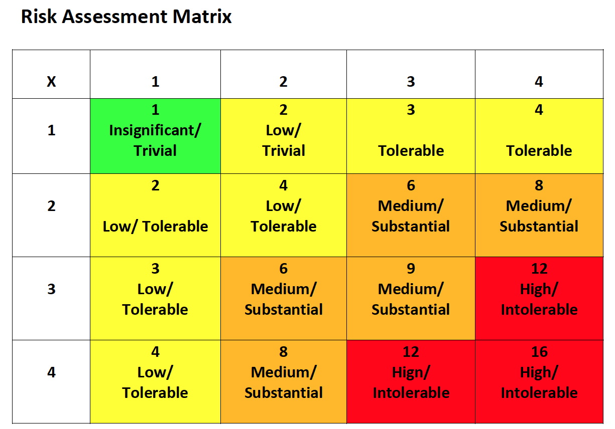

Completed by: Date: Review Date: Ongoing
Hazard | To Whom | Severity | Likelihood | Risk
Spread of Covid-19 through youth services provision and out into wider community | Children & Young People | 1 | 3 | 3
 | Staff | 3 | 3 | 9
 | Wider Community | 3 | 2 | 6
Existing Precautions |  | Additional Precautions | Who | When
- Hand-over of children young people youth centre/youth project and collection of children and young people at end of the session is structured to maintain social distancing of at least 2 metres. Parents/carers are instructed not to enter the Youth Service building. Children and young people are received into centre/project by a member of staff, maintaining social distancing protocols. Structured release of children and young people at the end of the session. https://www.education-ni.gov.uk/publications/implementing-social-distancing-education-settings-ni-coronavirus-covid-19
- Communication sent to all parents/carers that should their young person appear unwell they should not be sent to Youth Provision.
- Parents informed by letter that they are not to congregate at youth provision gates, entrances or within the outdoor spaces.
- Soap dispenser and paper towels/hand driers within toilets are fully stocked at the start of each day. Regular checks to be made throughout the day to ensure adequate supply.
- Handwashing techniques taught to all young people. It may be necessary to supervise some young people to ensure correct hand washing procedures.
Hazard
Spread of Covid-19 through youth services provision and out into wider community. (cont.)
Existing Precautions |  | Additional Precautions | Who | When
- Inform parents of hygiene expectations and for the need to communicate this message in the home environment.
- All staff/young people to wash their hands before coming to the youth provision, during the session, before going home and when they get home.
- Information sessions to demonstrate to children and young people appropriate hand washing techniques.
- Food or drinks will not be provided by Youth Settings whilst PHA guidance is in place.
- Staff monitor the visible health of young people, ensure parent emergency contact numbers are kept up to date.
- Public Health Advice on Covid-19 handwashing – Catch it, Bin it, Kill it posters around youth provision
- Discuss with parents the initial steps and agree key actions e.g. Parents may wish to send their hand wipes and sanitisers with pupils attending the Youth Programme/project.
- Hand sanitiser provided to youth provision for staff.
- Communicate to parents the importance of the government advice on catch it, bin it kill it.
- Keep all internal room and corridor doors propped open.
- Safety Agreement to be established with all young people relating to PHA guidance and adhering to social distancing measures. Parents to be informed of the agreement and any action which could be taken if this is not followed.
- Membership sign in sheet at entrance to be completed by young people participating in provision on a daily basis providing date of visit, name of young person. Up to date membership registration forms all participants in file attending provision.
Completed by: Date: Review Date: Ongoing
Hazard | To Whom | Severity | Likelihood | Risk
Suspected or confirmed case in youth centre. | Children & Young People | 1 | 2 | 2
 | Staff | 3 | 2 | 6
 | Wider Community | 3 | 1 | 3
Existing Precautions |  | Additional Precautions | Who | When
- Contact relevant agencies e.g. PHA, EA, etc.
- Close youth centre for a period of 72 hours where the member of staff or young person has only had restricted access to that area. If person displaying the symptoms had access to a number of rooms other than for transit purposes, then all areas accessed should be isolated for 72 hours. Cleaning to be completed after 72 hours and before reoccupation of the centre.
- In the case where the staff or young person may have spent their time in a number of rooms, all rooms should be closed.
- Inform staff.
- Contact parents with EA Communications or Management Committee agreed statement.
- Refer to Education Minster’s advice dated 16 March 2020 on what to do if someone develops symptoms of Covid-19 in a school or other educational setting.
- Youth Service must not name individuals.
Completed by: Date: Review Date: Ongoing
Hazard | To Whom | Severity | Likelihood | Risk
Suspected or confirmed case in staff member or young person or staff with a family connected to the youth provision. | Children & Young People | 1 | 2 | 2
 | Staff | 3 | 2 | 6
 | Wider Community | 3 | 2 | 6
Existing Precautions |  | Additional Precautions | Who | When
- Whole family to self-isolate for a period of 14 days in line with Government guidance (as of 20th March 2020).
- Consult PHA website for most up to date guidance.
- Normal system of work in relation to cleaning should be maintained with particular attention to high contact areas, toilets, door handles, telephones, grab rails.
- It is recommended that regular contact is made to Youth Service/Centre Manager.
Completed by: Date: Review Date: Ongoing
Hazard | To Whom | Severity | Likelihood | Risk
Shortage of staff, Absence of Youth Centre/Project Leadership | Children & Young People | 2 | 3 | 6
Existing Precautions |  | Additional Precautions | Who | When
- Redeploy youth service staff from a nearby location
- Consider combining youth provision whilst maintaining social distancing.
- Where Youth Worker/Young person ratios exceed DE recommendations– partial closure for certain programmes or part time / AM / PM programmes.
- Text alert service to parents to notify them of any exceptional closures due to insufficient staff cover.
- Notify EA/DE in the event of an exceptional closures.
Completed by: Date: Review Date: Ongoing
Hazard | To Whom | Severity | Likelihood | Risk
Shortage of support service staff such as, Building Supervisor/Cleaning or Admin Staff resulting in non-delivery of essential service | Children & Young People  Staff | 3 | 3 | 9
Existing Precautions |  | Additional Precautions | Who | When
- Contact EA Youth Service for cover arrangements
- Other staff from within the area to provide temporary cover for admin
- Reassign support staff to core health & safety functions within the youth setting
- Explore the option to share support staff with neighbouring youth provision.
Completed by: Date: Review Date: Ongoing
Hazard | To Whom | Severity | Likelihood | Risk
Reducing contact point activities. | Children & Young People  Staff | 1 | 1 | 1
Existing Precautions |  | Additional Precautions | Who | When
- Reducing equipment that involves contact between young people, i.e. board games, balls, etc.
- Disinfecting of equipment which young people are in regular contact with, should take place prior to and after each session.
- Door and corridor doors to be propped open (this is only during the period of Covid-19). All doors must be closed at the end of the service delivery day and cleaned prior to the beginning of the new session.
- Each young person to be assigned their own space and equipment which they use for the duration of the session.
- Consideration should be given to reconfiguration of the layout of tables and seating within the provision to aid social distancing and limit the amount of contact points.
Completed by: Date: Review Date: Ongoing
Hazard | To Whom | Severity | Likelihood | Risk
Risk of Fire | Children & Young People  Staff | 3 | 1 | 3
Existing Precautions |  | Additional Precautions | Who | When
- Routine weekly testing of the fire alarm system within the youth premises should continue as normal. Any faults to be logged to EA Maintenance.
- Fire escape routes kept clear at all times.
- Daily cleaning of bins, to avoid build-up of combustibles.
- Staff who are not familiar with the building should be made aware, on their first day of attendance, of actions to be taken in the event of a fire, emergency escapes routes and the position of the assembly point.
- Register kept of all persons present in the building.
- Fire Extinguishers must not be used to prop open doors, they must remain in situ.
- It may be prudent to carry out a fire drill. Remembering to maintain social distancing whilst vacating the building and at assembly points.
Completed by: Date: Review Date: Ongoing
Hazard | To Whom | Severity | Likelihood | Risk
Risk of an accident or injury during outdoor supervised areas. | Children & Young People | 1 | 1 | 1
Existing Precautions |  | Additional Precautions | Who | When
- Outdoor fixed playground equipment should not be used during this period.
- Staggering of breaks so limited number of young are in the outside spaces at any one time.
- No contact sports to be played during this time.
- Adequate supervision ratios.

Completed by: Date: Review Date: Ongoing
Hazard | To Whom | Severity | Likelihood | Risk
(Building Cleaning & Maintenance) Potential exposure to Covid-19 whilst cleaning | Children and young people | 1 | 3 | 3
 | Cleaning and youth work Staff | 3 | 3 | 9
 | Centre visitors and Wider community | 3 | 2 | 6
Existing Precautions |  | Additional Precautions | Who | When
- Adhere to PHA guidance for handwashing
- Appropriate PPE worn; disposable gloves and aprons used for all activities that may result in contamination, uniform, flat closed in shoes, hand sanitiser
- HSC Public Health Agency Guidance on Covid-19 displayed in school and referred to as necessary
- All touch/contact areas cleaned with germicidal disinfectant e.g. Shield/Protect
- Social Distancing measures in place
- Minimal number of cleaning staff working on a rotation basis.
- Where possible cleaning staff commence work when least number of people within the building
- Cleaning staff maintain social distance of at least 2 metres at all times
Completed by: Date: Review Date: Ongoing
Hazard | To Whom | Severity | Likelihood | Risk
(Building Cleaning & Maintenance) Risk of exposure to Covid-19 due to symptomatic or confirmed cases within location | Children and young people | 1 | 3 | 3
 | Cleaning and youth work Staff | 3 | 3 | 9
 | Centre visitors and Wider community | 3 | 2 | 6
Existing Precautions |  | Additional Precautions | Who | When
- Location closed for 72 hours
- Area closed for 72 hours
- After 72 hours cleaning staff complete an enhanced clean of area following normal system of clean with additional focus on touch/contact areas before the return of staff and children
- Apron, gloves or any contaminated items double bagged and disposed of appropriately after a single use
Completed by: Date: Review Date: Ongoing
Hazard | To Whom | Severity | Likelihood | Risk
(Building Cleaning & Maintenance) Risk of exposure to Covid-19 whilst preparing Centre for September during the months of July and August | Children and young people | 1 | 3 | 3
 | Cleaning and youth work Staff | 3 | 3 | 9
 | Centre visitors and Wider community | 3 | 2 | 6
Existing Precautions |  | Additional Precautions | Who | When
- Adhere to PHA guidance for handwashing
- Appropriate PPE worn; disposable gloves and aprons used for all activities that may result in contamination, uniform, flat closed in shoes, hand sanitiser
- HSC Public Health Agency Guidance on Covid-19 displayed in Centre and referred to as necessary
- All touch/contact areas cleaned with germicidal disinfectant e.g. Shield/Protect
- Social Distancing measures in place
- Cleaning staff have designated cleaning area
- Where possible cleaning staff commence work when least number of people within the building
- Cleaning staff maintain social distance of at least 2 metres at all times
- Cleaning staff do not undertake duties which have the need for 2 people, i.e. lifting of tables from rooms

