Project Area
Address
Postcode
Council Area
Main Telephone

Youth Service
Area Based Youth Work Risk Assessment
(Covid-19)
(Including Outreach & Detached)

July 2020

LIST OF ASSESSED RISKS
Spread of Covid-19 through Youth Services and into wider community 5
Large group gatherings 6
Spread of Covid-19 through Youth Services and into wider community 7
Use of external premises (including use of transport) 9

Sign off and Approval
Completed By
Approval

Risk Assessment Matrix
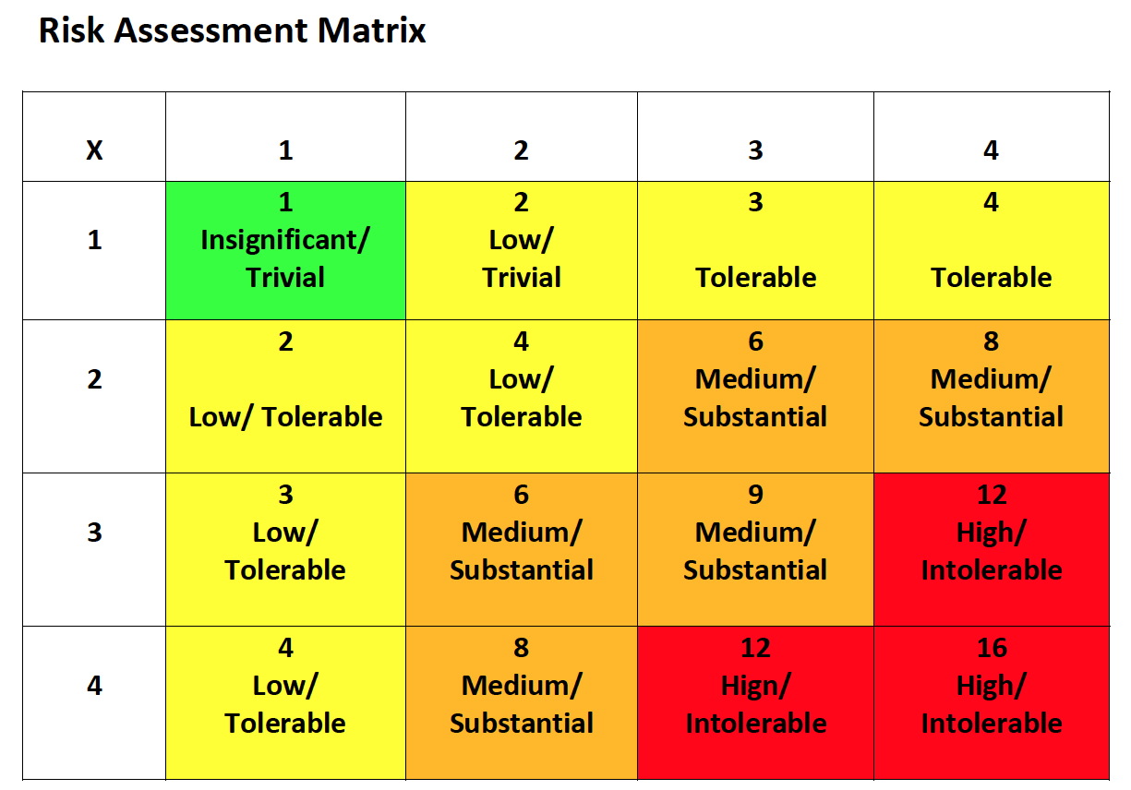

Completed by: Date: Review Date: Ongoing
Hazard | To Whom | Severity | Likelihood | Risk
Large group gatherings | Young people | 3 | 3 | 9
 | Staff | 3 | 3 | 9
Existing Precautions |  | Additional Precautions | Who | When
- Response plan in place with PSNI and staff briefed accordingly
- Street work protocols in place and implemented
- PPE Equipment available to staff where requested
- PHA social distancing guidelines to be adhered to at all times between staff and staff and young people
- Where social distancing measures are not possible, staff should withdraw and inform PSNI
- Staff to advise group to disperse for their health and safety and take appropriate measures where possible to support young people to go home
- If group will not disperse or risk is deemed too high to proceed with engagement, PSNI should be informed and staff withdraw
- Staff to work in groups of 2 (minimum) and maintain contact with other staff teams throughout session
- Meeting points to be established for staff to convene on regular intervals
- Where young person is at risk to themselves or others, PSNI to be informed and any further referrals made as required
Completed by: Date: Review Date: Ongoing
Hazard | To Whom | Severity | Likelihood | Risk
Spread of Covid-19 through Youth Services and into wider community | Young people | 1 | 3 | 3
 | Staff | 3 | 3 | 9
 | Wider community | 3 | 2 | 6
Existing Precautions |  | Additional Precautions | Who | When
- All staff to wash their hands before engaging in youth work sessions, before going home and when they get home
- Hand sanitiser to be provided to all youth work staff for use during sessions
- PHA social distancing guidelines to be adhered to at all times – staff may be required to reduce the number of group or stagger sessions to comply with 2 metre gaps
- A full record of each meeting must be maintained. This is required to facilitate contact tracing should a suspected case arise
- Staff will contract with young people adherence to PHA guidance around catching coughs and sneezes in tissues – Following the ‘Catch it, Bin it, Kill it’ advice and to avoid touching face, eyes, nose or mouth with unclean hands.
- Discuss with parents the initial steps and agree key actions e.g. Parents may wish to send their hand wipes and sanitisers with pupils attending the Youth Programme.
- Communicate to parents the importance of the government advice on catch it, bin it kill it.
- Handwashing techniques taught to all young people. It may be necessary to supervise some young people to ensure correct hand washing procedures.
- Inform parents of hygiene expectations and for the need to communicate this message in the home environment.

Hazard
Spread of Covid-19 through Youth Services and into wider community (Cont.)
Existing Precautions |  | Additional Precautions | Who | When
- Staff must monitor the visible health of young people and contact parents if possible, to do so where staff have concerns
- Staff carry and distribute safety guidance from PHA in strength based language; this should be referred to prior to all sessions
- Code of conduct to be established with all young people relating to PHA guidance and adhering to social distancing measures. Parents to be informed of code of conduct and any action which could be taken if this is not followed.
Completed by: Date: Review Date: Ongoing
Hazard | To Whom | Severity | Likelihood | Risk
Use of external premises or 3rd part activity providers (including Linked Transport Use) | Children & Young People | 4 | 2 | 8
 | Staff | 4 | 2 | 8
Existing Precautions |  | Additional Precautions | Who | When
Use of external premises (e.g. a nearby youth centre) or 3rd party providers will only take place in agreement with the school and in line with their risk management protocols. In the rare event (extenuating circumstances) where external premises or 3rd providers are to be used the following precautions will be in place;
- Health and safety checklist to be completed and recorded during a meeting with facility manager to ensure appropriate measures are in place to guarantee the safety of young people and staff. This should include measures relating to a suspected or confirmed Covid case in the centre and contact tracing measures in place
- Staff to only use areas which are appropriately risk assessed – this must be completed prior to all sessions to ensure the space allows adherence to PHA guidance
- Handwashing facilities must be available and soap dispenser and paper towels/hand driers within toilets fully stocked at the start of each session. Regular checks to be made throughout the session to ensure adequate supply.
- Areas or facilities that don’t allow social distancing should not be entered by staff or young people; the session should be postponed, and a full report provided to line manager

Hazard
Use of external premises or 3rd part activity providers (including linked transport use) (Cont.)
Existing Precautions | Additional Precautions | Who | When
- If other facility users are not maintaining appropriate standards to ensure the safety of young people and staff, staff should disengage and move to another area if suitable. The session should be ended if this is not possible and full report provided to line manager.
- Hand-over of children and young people at the premises or with a 3rd party provider and collection of children and young people at end of the session is structured to maintain social distancing in line with current PHA guidance. Parents/carers are instructed not to enter the building. Children and young people are received into project by a member of staff, maintaining social distancing protocols. Structured release of children and young people at the end of the session. Facility manager must be informed and agree to this practice.
Where the use of external premises or 3rd party providers involve travel in a shared vehicle the following precautions must be in place;
- Limit number of vehicle occupants PHA/EA guidance (e.g. 17 seater minibus a Max of 2 persons based on the 2 metres social distancing and 3 persons based on the 1 metre social distancing – these figures include the driver).
- Provide opportunity to sanitise hands entering and exiting vehicle
- Disinfection vehicle interior using recommended products when the existing group has completed use, no other groups or young people can use this vehicle until this happens
- Avoid use of forced air ventilation/air con. Favour open windows

