

**Project Worker** (P/T)

**Do Something Active**

**JOB REF/ PW2020**

**INFORMATION PACK**

**June 2020**

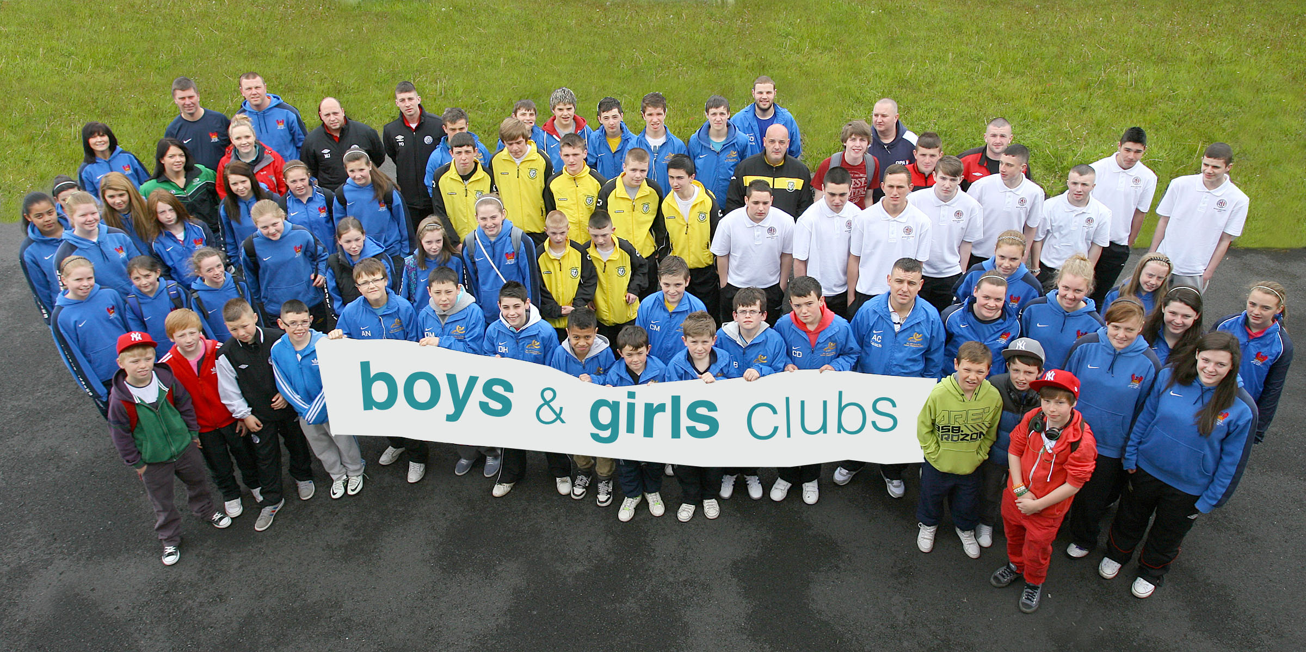

reach: involve : enjoy : achieve

**Thank you for your interest in the post of**

**Project Worker - Do Something Active**

The information within this application pack is designed to give applicants a fuller picture of the post and a brief introduction to **Boys & Girls Clubs.**

After reading through the pack, we trust that you will be interested in applying for the post and ask that you complete the Application Form in Word Version and return it by **5.00 pm Tuesday 23rd June 2020.**

**Applications should be identified in the email subject area as a Job Application with Reference No and addressed to:**

|  |
| --- |
| **post@boysandgirlsclubs.net** |

It is anticipated that Online interviews will take place on **Friday 26th June 2020**. (Invite & details to follow).

Returned applications forms (as attachment in Word format) from a personal email address will be considered and treated as signed by the applicant and all applications received by the (above) closing time will be acknowledged.

Applicants will be informed by email if they have been shortlisted or not for an online interview.

**You will find the following enclosed within this pack:**

1. **Introduction to Boys & Girls Clubs**
2. **General Information and Appointment Notes**
3. **Pre-employment checks**
4. **Job Description and Person Specification**
5. **Application Form – includes Equality of Opportunity Monitoring Questionnaire & Disclosure of Criminal Convictions Form (also available to download separately in Word format)**

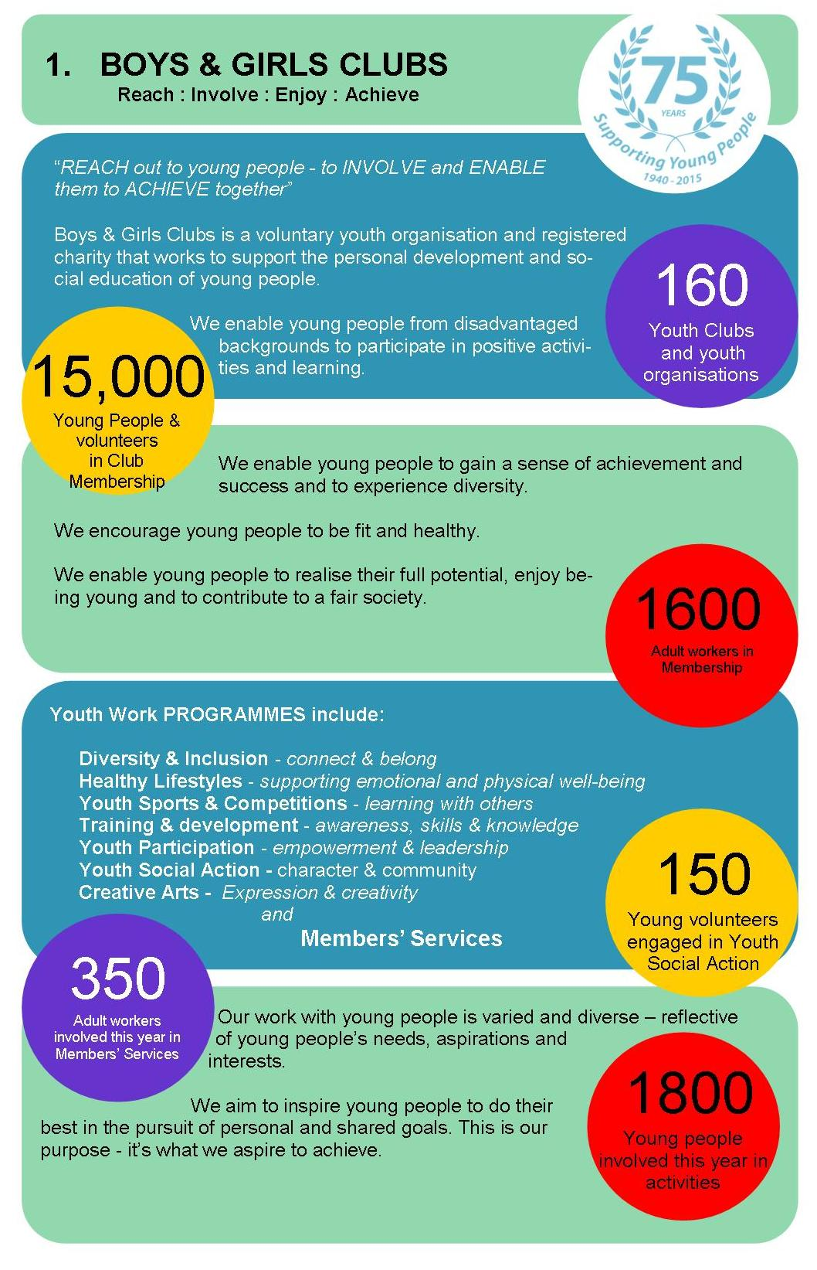

**2. GENERAL INFORMATION AND APPOINTMENT NOTES:**

**Project Worker - Do Something Active**

The following outlines basic information about working terms and conditions. Full terms and conditions will be detailed in a Contract of Employment, which will be provided to the successful candidate.

* **Location**

The Do Something Active Project Worker will proactively support and develop the presence of the Do Something Active project Online and throughout the designated target areas of Greater Belfast.

  **Hours of Work**

This is a part-time post for an average of **14hours/2 days per week** and the Project Worker will be required to work variable hours each week, which will involve regularly working on evenings and occasional weekends and public holidays.

* **Length of contract**

This post is available on a **fixed-term basis for the duration of the project.** The successful candidate will be issued with a detailed Contract of Employment within 4 weeks from the date of commencing work.

* **Benefits**
* **Salary:**£21,682 JNC Pay Scales - Point 11 (**pro-rata** forthe agreed hours)

* **Annual Leave, Public & Privilege Holidays:**The leave entitlement is 20 days Annual Leave and 10 days Public Holidays (calculated pro-rata for part-time employees). The leave-year runs from 1st January to 31st December.
* **Pension:**the post holder may join the company pension scheme.

  **Probationary Period -** There will be a probationary period of 4 months.

  **Smoking Policy & Role Modelling**

Boys & Girls Clubs operates a strict non-smoking policy which also applies to the use of e-cigarettes. All personnel, staff and volunteers, are prohibited from smoking in Boys & Girls Clubs' premises, when present at or leading on activities and events and at any time in the presence of children and young people. Staff and volunteers provide positive role modelling to the children and young people with whom we work and any behaviour deemed inconsistent with professional standards of best practice is not permitted.

  **Equality of Opportunity**

Boys & Girls Clubs is committed to equality of opportunity in employment and welcomes applications from all suitably qualified persons, irrespective of religious belief, gender, physical ability, race, political opinion, age, marital status, sexual orientation or whether or not they have dependants. All applicants for employment will be considered on the basis of merit.

To demonstrate our commitment to equality in employment we need to monitor the community background of all employees and job applicants as required by The Fair Employment and Treatment (NI) Order 1998. Therefore we require all job applicants to complete and return a Monitoring Questionnaire. Personnel involved in either the short-listing or interview selection processes will not see its contents. However, if you do not complete this questionnaire, and return it with your completed and signed Application Form, we will not be able to process your application to the next stage of selection.

**Child Protection (Safeguarding)**

In compliance with Child Protection legislation the preferred candidate must agree to an AccessNI managed Police check.

**3. DO SOMETHING ACTIVE - PROJECT INFORMATION**

**INTRODUCTION**

Gender inequality is entrenched in NI society and results in poorer health outcomes for girls & young women. To help address this issue, “Do Something Active” is an innovative, peer-to-peer education model where girls & young women in targeted areas of Belfast are supported & equipped to directly lead their peers on important health issues including exercise, nutrition, mental resilience and physical health.

**“Do Something Active”** is a youth-led project which aims to equip teenage girls & young women as peer health educators and leaders in their youth clubs and local communities.

**Short term impact**

We aim to Increase the skills & knowledge base in local communities on issues surrounding health, physical activity, nutrition and overall health.

**Medium term impact**

Cultivating grass-roots level female leadership and coaching capacity in disadvantaged areas.

**Long term impact**

Promoting healthy behaviour & practices and contribute to the overall development of female coaches.

**Outcomes**

The project will include the training & mentoring of 24 young women *Health Champions* across Greater Belfast to lead in the delivery of a comprehensive physical activity and nutrition programme for girls & young women. Additionally, the project staff team, with the help of a registered dietician, will support the *Health Champions* to achieve the following outcomes:

* Train young women as Health Champions in leadership, physical activities and healthy eating;
* Support Health Champions to provide UK Sports Leadership Awards to others;
* Provide healthy eating & lifestyles sessions to project participants
* Provide physical activity sessions to 200 young people by end of project
* Train 24 Health Champion in Food Values & food safety and preparation
* Support delivery of Social Action projects in health-related programmes

**4a. JOB Description & PERSON SPECIFICATION**

**JOB DESCRIPTION – Project Worker - Do Something Active**

**Job Title:** Project Worker (P/T fixed term)

**Salary:** £21, 682 pro-rata - 14 hours weekly (2 days)

**Reports to**: Sports Officer, Boys & Girls Clubs

**Job Purpose**: **Youth leadership promoting physical activities, sport, nutrition, health and well-being and provision of project monitoring & administration.**

The post holder will recruit and engage effectively in sport, physical activity & healthy eating design with girls & young women to support and develop their health & well-being, peer-leadership and community volunteering. The post holder will work to deliver set project targets for the Do Something Active project.

The Project Worker will proactively support and contribute to the development of youth participation, empowerment and health & well-being through our Do Something Active project and its leadership of girls & young women in designated youth clubs in the Belfast area. S/he will support project members and their participation levels through health promotion and active engagement in sports, training and direct contact with young people.

**Main Duties & Key Responsibilities**

1. Providepresence and raise the profile of the *Do Something Active* project throughout the designated target areas (Online & Greater Belfast),proactively developing youth participation in the life of the local youth community and the Organisation.
2. Promote youth engagement with the Do Something Active project by providing support and supervision to the girls & young women (Health Champions) who will lead on the project.
3. As part of a youth work team, to support and quality assure the design, delivery, co-ordination and evaluation of the Do Something Active project activities and events and to ensure that all activities are compliant with current legislation; that policy and best practice are maintained throughout with regard to all project work.
4. Design and participate in local Do Something Active initiatives to shape and developpartnership work and Do Something Active partner groups in designated areas, including the organisation of training design and delivery.
5. Ensure that the project activities consistently promote a message of positive community relations, health and well-being, and contribute to the shaping of strategies, interventions and practice models which enable young people to build resilience to negative competing influences, lifestyle attitudes and risky, damaging and dangerous behaviours.
6. To facilitate and develop youth participation in decision-making, through building positive relationships with young people, and those who work on their behalf.
7. To create awareness of, and signposting to, services for young people on a range of youth issues including employability, drugs and alcohol abuse, sexual health etc
8. To maximise and enhance youth participation and empowerment by utilising and developing Online work and electronic communications, social media platforms, networksand other appropriate forums of benefit to the project, its profile and beneficiaries.
9. To ensure that regular meetings (weekly & Online as appropriate) with project participants, project and organisation staff are properly co-ordinated, scheduled and reported, so that relationships are built and impact is maximised,
10. Ensure Project Action Plans, budgets and all administrative procedures are implemented fully and that further opportunities are identified to optimise project and programme outcomes.
11. To ensure that all project reviews, monitoring and evaluation processes are fully implemented on behalf of project participants, Boys & Girls Clubs, its sponsors and partner organisations.

**PERSON SPECIFICATION**

**Key Skills & Experience:**

1. Excellent organisational skills, including the ability to assess & achieve work targets.
2. Hold a coaching qualification and/or demonstrable experience of achievement in at least one sport or physical exercise/activity.
3. Keen interest and ability to deliver coaching in physical exercise; demonstrable experience and interest in providing/sharing with others health, food, diet & nutrition information & instruction.
4. Ability to develop and implement innovative concepts and plans to meet set targets and to work to deadlines, using own initiative and within budget.
5. Good computer skills and experience of using Online, social media & networking work with young people and those who support them.
6. Professional communications skills with the ability to build rapport with members via a range of appropriate communication methods including online engagements & effective report writing.
7. A good understanding of the needs and interests of young people and youth work sector.
8. Knowledge of youth, community, health & nutrition issues and a commitment to work with young people and those who work on their behalf across Northern Ireland.

PREFERABLE

1. Applicants who hold a full driving licence, which enables the holder to drive in Northern Ireland for a business related purpose, and have access to a form of transport, which will permit the applicant to meet the requirements of the post in full..

APPLICATION FORM

**Project Worker (PT)**

**Do Something Active**

**JOB REF: PW2020**

###### 

All questions must be answered. The receipt of an Application Form via a legitimate personal email will be accepted as a signed application when received by closing time:

Completed applications must arrive no later than

**5.00 pm Thursday 23rd June 2020**

**LATE APPLICATIONS WILL NOT BE ACCEPTED**

**IN CONFIDENCE**

For office use only:

Applicant's Name: _________________________ Applicant No _____________

NOTES:

|  |
| --- |
| **Personal Details**  Forename (s): _______________________________________________________    Family Name: _______________________________________________________  Address: _______________________________________________________  _______________________________________________________    Postcode: _____________________­­­­­______  Home Tel No: _______________________  Mobile No. ________________________    Email Address : _________________________________________________________  National Insurance Number: ______________  Do you hold a current full UK driving licence? Yes / No (underline)    Are you a car owner or do you have access to a form of transport which will enable you to carry out the duties of this post in full? Yes / No (underline)  How did you learn about this job? __________________________________________ |

**Your Qualifications**

|  |  |  |
| --- | --- | --- |
| **Type of Exam**  (GCSE, NVQ, A Level, BTEC, Degree, Post-Graduate etc) | **Subject** | **Grade** |
|  |  |  |

**Are you currently employed? Yes / No** **(please underline your response).**

Current Salary: ______________________

Notice Required: ______________________

**Previous Work (**Start with present or most recent job)

|  |  |  |  |
| --- | --- | --- | --- |
| **Name & Address of Employer** | **Salary & Dates Employed** | **Type of Job** (give brief description of duties) | **Reason for Leaving** |
|  |  |  |  |
|  |  |  |  |
|  |  |  |  |
|  |  |  |  |
|  |  |  |  |
|  |  |  |  |

[Please attach an additional sheet if required]

**Short- listing Criteria**

BOYS & GIRLS CLUBS may decide to shortlist for interview only those applicants who appear from the available information to be the most suitable candidates for the post in terms of relevant skills, experience and ability. It is therefore essential that applicants fully describe how they meet each particular requirement, including relevant timescale/duration (e.g. provide dates), of the ‘Eligibility Criteria’ and possible ‘Short-listing Criteria’ as indicated in the Person Specification.

**Answer all questions in the spaces provided; additional sheets will not be included.**

|  |
| --- |
| 1. Programme delivery experience within a sport, youth work or educational setting ***(Max. 300 words).*** |
| 1. Promoting, organising and co-ordinating youth, sport & health activities & events ***(Max. 300 words).*** |

|  |
| --- |
| 1. Experience of work with young people and the maintenance of relationships with them through a structured and planned programme (e.g. via programme or curriculum - ***Max. 300 words).*** |

|  |
| --- |
| 1. Your familiarity & use of IT and social media and online work ***(Max. 300 words).*** |

|  |
| --- |
| 1. Your record of delivering effective results within a programme of work. ***(Max. 300 words)*** |

**Declaration of Criminal Convictions and Monitoring Questionnaire**

Is there any reason why you cannot work with children or young people? **Yes / No** (please underline your response).

In compliance with our policy and current legislation, applicants must fully complete the attached forms and return in a separate sealed envelope:

[1] Declaration of Criminal Convictions

[2] Monitoring Questionnaire - Equality of Opportunity

**Reference**

All offers of employment are subject to receipt of satisfactory written references. Please provide the names, telephone numbers, addresses and email addresses of two referees, one of whom should be your present or most recent employer/line manager, and one who knows/has known you in a work capacity and can comment on your suitability for this post.

|  |  |
| --- | --- |
| **First Referee**  Name: ___________________________  Address ___________________________  ___________________________  ___________________________  Tel: ___________________________  Email: ___________________________  Occupation: _______________________  Relationship to you: ___________________________________ | **Second Referee**  Name: ___________________________  Address ___________________________  ___________________________  ___________________________  Tel: ___________________________  Email: ___________________________  Occupation: _______________________  Relationship to you: ___________________________________ |

**Declaration**

I declare that the information provided in this Application Form is, to the best of my knowledge,

True and complete.

Signed: ________________________________ Date: _ _ / _ _ / _ _ _ _

**4b. DISCLOSURE OF CRIMINAL CONVICTION**

**Please read this information carefully.**

**Name of Applicant: ___________________________ Job Title: ___________________________**

**STATEMENT OF NON-DISCRIMINATION**

Boys & Girls Clubsis committed to equal opportunity for all job applicants, including those with criminal convictions. Information about criminal convictions is requested to assist the selection process and will be taken into account only when the conviction is considered relevant to the role. Any disclosure will be seen in the context of the criteria of the role, the nature of the offence and the responsibility for the care of children and young people, volunteers and employees. **Applicants are required to declare any convictions, cautions, reprimands and final warnings not protected by legislation.**

**ADVICE TO APPLICANTS**

The disclosure of a criminal record or other information will not debar you from registration or appointment unless Boys & Girls Clubs considers that the conviction renders you unsuitable. In making this decision Boys & Girls Clubs will consider the nature of the offence, how long ago it was committed, your age at that time and other factors which may be relevant. This information will be verified through an appropriate AccessNI Enhanced Disclosure check. If you have received a formal caution or are currently facing prosecution for a criminal offence you should also bring this to our attention given the “exempted” nature of the role.

Please complete and sign this Declaration Form (below) accurately and return this with your application form. An arrangement may be made with you to discuss any convictions if clarification is required.

**Thanking you in advance for your co-operation.**

|  |
| --- |
| **DECLARATION**  **Do you have any convictions that are not “protected” as defined by the Rehabilitation of Offenders (Exceptions) (Northern Ireland) Order 1979, as amended in 2014?**  **Yes**  **No**  If ‘Yes’, please state the nature, date(s) and sentence of the offence(s) and provide any other information youfeel may be of relevance, such as**:** the circumstances of the offence/incident; any relevant developments in your situation since; and whether or not you feel the conviction has relevance to this post. (Please continue on an additional separate page if required.)  _________________________________________________________________________________________________________________________________________________________________________________________________________________________________________________________________________________________________________________________________________________________________________________________________________________________________________  I declare that any and all answers provided herein are complete and correct to the best of my knowledge and I have informed Boys & Girls Clubs' Monitoring Officer in writing of any pending future convictions. I understand that I have applied for a role which is a Regulated Activity Position as defined by the Safeguarding Vulnerable Groups (NI) Order 2007 (as amended by the Protection of Freedom Act 2012) and which also falls within the definition of an “exempted” position as provided for by the Rehabilitation of Offenders (Exceptions) Order (NI) 1979 (as amended in 2014).  **I give my consent for an AccessNI* check to take place and for this information to be shared only with relevant persons nominated as part of Boys & Girls Clubs' risk assessment and appointment procedures.**  **(Signature) ___________________________________ Date _ _ / _ _ / _ _ _ _** |

* Boys & Girls Clubs complies with the AccessNI Code of Practice. Further information is available at

[www.boysandgirlsclubs.net](http://www.cypni.net) and [www.accessni.gov.uk](http://www.accessni.gov.uk)

4c. MONITORING QUESTIONNAIRE - EQUALITY OF OPPORTUNITY

**Job Title _____________________________ Job Ref: ____________ Date: _ _ / _ _ / _ _ _ _**

Boys & Girls Clubs is committed to equality of opportunity in employment and aims to select and employ the best person for each post. All job applicants and employees shall receive equal treatment regardless of gender, marital status, age, disability, socio-economic circumstances, health, sexuality, religious or political belief, colour, race and ethnic or national origin.

We will encourage positive attitudes and behaviour towards groups and individuals and will strive to eradicate prejudice and discrimination by promoting equality of opportunity in all areas of our work and organisational structure.

To demonstrate our commitment to equality in employment we need to monitor the community background of all employees and job applicants as required by the Fair Employment and Treatment (Northern Ireland) Order 1998.

Regardless of whether we practice religion, most of us in Northern Ireland are perceived as either Catholic or Protestant. We are therefore required to ask you to indicate your community background by ticking the appropriate box below.

|  |  |  |  |  |  |  |  |  |  |
| --- | --- | --- | --- | --- | --- | --- | --- | --- | --- |
| **DECLARATION**  *I am a member of the Catholic community* I am a member of the Protestant community I am a member of neither the Protestant nor *the Catholic community*  Please indicate whether you are: *Female*  *Male*  Date of Birth: __ /__ / ____  **ETHNIC ORIGIN** **(please tick appropriate box.)**   |  |  |  | | --- | --- | --- | | **Bangladeshi** | **Black African** | **Black Caribbean** | | **Black/Other** | **Chinese** | **Indian** | | **Pakistani** | **White** | **Other (Please specify):** |   N.B. If you do not complete this questionnaire and return it with your completed Application Form, we will be unable to process your application to the next stage of the selection process.  **\*\* This form will be separated from your Application Form and will not be seen by the selection panel.**  **Thanking you in advance for your completed and signed Application Form (4a) b) & c)** |