**THE PADDY DUFFY MEMORIAL AWARD**

**YOUTH BURSARY**

*Mr Paddy Duffy served as a Vice President and Board member of Boys & Girls Clubs for many years. A much-loved voluntary youth worker and respected and valued member of Boys & Girls Clubs.*

*Happy the Peacemakers for they shall be called the sons of God.*

***Rest in Peace 1928 - 2002***

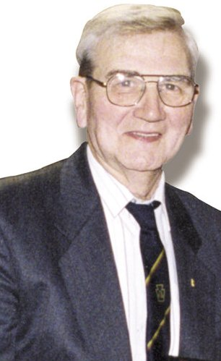

The Paddy Duffy Award was established as a memorial award in 2002 by the principal officers & staff of Boys & Girls Clubs. The Award aims to recognise and preserve the values and principles by which Paddy lived and shared with others through his life and voluntary youth work. The Paddy Duffy Award is intended to support a nominated young person who has demonstrated these values in their everyday life and youth work.

**The personal qualities that Paddy LIVED & valued most:**

* Selflessness
* Resilience
* Effort
* Fair Play for all
* Respect & consideration for others
* Commitment to volunteerism
* Sense of fun & good humour
* Commitment to self-improvement

*“Boys & Girls Clubs value the important contribution Paddy made and believe that his legacy should be continued through the Bursary Award*”.

Do you know any young person/young volunteer who consistently demonstrates the same qualities as Paddy?

Do you think that the Paddy Duffy Bursary would assist your nominee (young person) in their personal and vocational development?

If yes, complete and return the attached Nomination Form to Boys & Girls Clubs.

